**Project Planning Phase**

**Project Planning Template (Product Backlog, Sprint Planning, Stories, Story points)**

|  |  |
| --- | --- |
| Date | 16 June 2025 |
| Team ID | LTVIP2025TMID34708 |
| Project Name | Transfer Learning-Based Classification of Poultry Diseases for Enhanced Health Management |
| Maximum Marks | 5 Marks |

**Product Backlog, Sprint Schedule, and Estimation (4 Marks)**

Use the below template to create product backlog and sprint schedule

| **Sprint** | **Functional Requirement (Epic)** | **User Story Number** | **User Story / Task** | **Story Points** | **Priority** |
| --- | --- | --- | --- | --- | --- |
| Sprint-1 | Data Collection & Preprocessing | USN-1 | As a developer, I want to collect poultry disease image and symptoms data from multiple datasets and sources. | 3 | High |
| Sprint-1 | Data Collection & Preprocessing | USN-2 | As a developer, I want to preprocess, clean, and augment the collected data to prepare it for transfer learning models. | 5 | High |
| Sprint-2 | Model Development | USN-3 | As a data scientist, I want to apply transfer learning to build a disease classification model for poultry images. | 8 | High |
| Sprint-2 | Model Testing & Validation | USN-4 | As a data scientist, I want to test and validate the model using a separate dataset to check accuracy and reliability. | 4 | Medium |
| Sprint-3 | Mobile App Integration | USN-5 | As a user, I want to upload poultry images and symptoms in the app to receive immediate disease predictions. | 5 | High |
| Sprint-3 | API & Backend Deployment | USN-6 | As a developer, I want to deploy the trained model and build APIs for the app to fetch predictions in real time. | 6 | High |
| Sprint-4 | Recommendation & Alert System | USN-7 | As a user, I want to receive disease-specific treatment recommendations and management tips based on results. | 3 | Medium |
| Sprint-4 | Notifications & Personalization | USN-8 | As a farmer, I want to receive disease alerts and personalized management notifications to prevent disease spread. | 5 | High |

**Project Tracker, Velocity & Burndown Chart: (4 Marks)**

| **Sprint** | **Total Story Points** | **Duration** | **Sprint Start Date** | **Sprint End Date (Planned)** | **Story Points Completed (as on Planned End Date)** | **Sprint Release Date (Actual)** |
| --- | --- | --- | --- | --- | --- | --- |
| Sprint-1 | 8 | 5 Days | 1 July 2025 | 5 July 2025 | 6 | 5 July 2025 |
| Sprint-2 | 12 | 5 Days | 8 July 2025 | 12 July 2025 | 8 | 12 July 2025 |
| Sprint-3 | 11 | 5 Days | 15 July 2025 | 19 July 2025 | 7 | 19 July 2025 |
| Sprint-4 | 8 | 5 Days | 22July 2025 | 26 July 2025 | 5 | 26 July 2025 |

**Velocity:**

Imagine we have a 10-day sprint duration, and the velocity of the team is 20 (points per sprint). Let’s calculate the team’s average velocity (AV) per iteration unit (story points per day)

**If the total story points completed = 6 + 8 + 7 + 5 = 26 points over 20 days (4 sprints, 5 days each):**

**Average velocity (AV) = total story points completed / total days  
= 26 / 20  
= 1.3 story points per day**

**Burndown Chart:**

A burn down chart is a graphical representation of work left to do versus time. It is often used in agile[software development](https://www.visual-paradigm.com/scrum/what-is-agile-software-development/) methodologies such as [Scrum](https://www.visual-paradigm.com/scrum/scrum-in-3-minutes/). However, burn down charts can be applied to any project containing measurable progress over time.

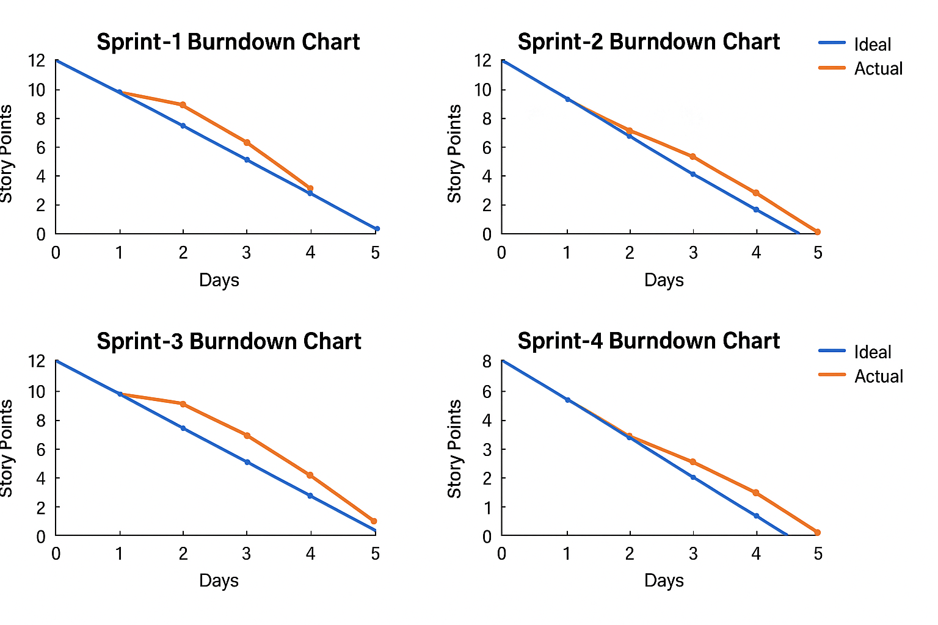

[**https://www.visual-paradigm.com/scrum/scrum-burndown-chart/**](https://www.visual-paradigm.com/scrum/scrum-burndown-chart/)

[**https://www.atlassian.com/agile/tutorials/burndown-charts**](https://www.atlassian.com/agile/tutorials/burndown-charts)

**Reference:**

[**https://www.atlassian.com/agile/project-management**](https://www.atlassian.com/agile/project-management)

[**https://www.atlassian.com/agile/tutorials/how-to-do-scrum-with-jira-software**](https://www.atlassian.com/agile/tutorials/how-to-do-scrum-with-jira-software)

[**https://www.atlassian.com/agile/tutorials/epics**](https://www.atlassian.com/agile/tutorials/epics)

[**https://www.atlassian.com/agile/tutorials/sprints**](https://www.atlassian.com/agile/tutorials/sprints)

[**https://www.atlassian.com/agile/project-management/estimation**](https://www.atlassian.com/agile/project-management/estimation)

[**https://www.atlassian.com/agile/tutorials/burndown-charts**](https://www.atlassian.com/agile/tutorials/burndown-charts)